**COGNIZANT - DIGITALNURTURE4.0**

**DEEPSKILLING JAVA FSE**

**WEEK 02: Junit Basic Testing Exercise**

**EXERCISE 1: SETTING UP JUNIT**

**Directory Structure (junit-demo)**

junit-demo/

├── pom.xml

├── src/

├── main/

│ └── java/

│ └── com/

│ └── example/

│ └── App.java

└── test/

└── java/

└── com/

└── example/

└── AppTest.java

**pom.xml**

<project xmlns="http://maven.apache.org/POM/4.0.0"

xmlns:xsi="http://www.w3.org/2001/XMLSchema-instance"

xsi:schemaLocation="http://maven.apache.org/POM/4.0.0

http://maven.apache.org/xsd/maven-4.0.0.xsd">

<modelVersion>4.0.0</modelVersion>

<groupId>com.example</groupId>

<artifactId>junit-demo</artifactId>

<version>1.0-SNAPSHOT</version>

<dependencies>

<dependency>

<groupId>junit</groupId>

<artifactId>junit</artifactId>

<version>4.13.2</version>

<scope>test</scope>

</dependency>

</dependencies>

</project>

**App.java**

package com.example;

public class App {

public int add(int a, int b) {

return a + b;

}

}

**AppTest.java**

package com.example;

import org.junit.Test;

import static org.junit.Assert.*;

public class AppTest {

@Test

public void testAdd() {

App app = new App();

assertEquals(10, app.add(3, 7));

}

}

**OUTPUT**

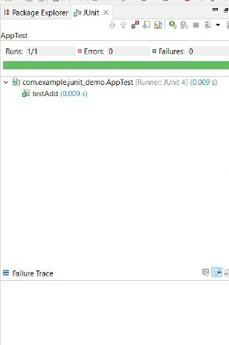

**EXERCISE 2: ASSERTIONS IN JUNIT**

**Directory Structure (junit-demo)**

junit-demo/

├── pom.xml

├── src/

├── main/

│ └── java/

│ └── com/

│ └── example/

│ └── App.java

└── test/

└── java/

└── com/

└── example/

├── AppTest.java

└── AssertionsTest.java

**AssertionsTest.java**

package com.example;

import org.junit.Test;

import static org.junit.Assert.*;

public class AssertionsTest {

@Test

public void testAssertions() {

// Assert equals

assertEquals(5, 2 + 3);

// Assert true

assertTrue(5 > 3);

// Assert false

assertFalse(5 < 3);

// Assert null

assertNull(null);

// Assert not null

assertNotNull(new Object());

}

}

**OUTPUT**



**EXERCISE 3: ARRANGE-ACT-ASSERT (AAA) PATTERN, TEST FIXTURES, SETUP AND TEARDOWN METHODS IN JUNIT**

**Directory Structure (junit-demo)**

junit-demo/

├── pom.xml

├── src/

│ ├── main/

│ │ └── java/

│ │ └── com/

│ │ └── example/

│ │ └── App.java

│ └── test/

│ └── java/

│ └── com/

│ └── example/

│ └── AppTest.java

**App.java**

package com.example;

public class App {

public int multiply(int a, int b) {

return a * b;

}

}

**AppTest.java**

package com.example;

import org.junit.Before;

import org.junit.After;

import org.junit.Test;

import static org.junit.Assert.*;

public class AppTest {

private App app;

@Before

public void setUp() {

// Arrange

app = new App();

System.out.println("Setup done");

}

@After

public void tearDown() {

app = null;

System.out.println("Teardown done");

}

@Test

public void testMultiply() {

// Act

int result = app.multiply(5, 6);

// Assert

assertEquals(30, result);

}

}

**OUTPUT**



**NAME: HARINI G  
SUPERSET ID: 6385037**